Software Requirements Specification

for

Library Management System

Version 1.0 approved

Prepared by Rasel Islam

Farmingdale State College

October 2,2025

Table of Contents

Table of Contents ii

Revision History ii

1. Introduction 1

1.1 Purpose 1

1.2 Document Conventions 1

1.3 Intended Audience and Reading Suggestions 1

1.4 Product Scope 1

1.5 References 1

2. Overall Description 2

2.1 Product Perspective 2

2.2 Product Functions 2

2.3 User Classes and Characteristics 2

2.4 Operating Environment 2

2.5 Design and Implementation Constraints 2

2.6 User Documentation 2

2.7 Assumptions and Dependencies 3

3. External Interface Requirements 3

3.1 User Interfaces 3

3.2 Hardware Interfaces 3

3.3 Software Interfaces 3

3.4 Communications Interfaces 3

4. System Features 4

4.1 System Feature 1 4

4.2 System Feature 2 (and so on) 4

5. Other Nonfunctional Requirements 4

5.1 Performance Requirements 4

5.2 Safety Requirements 5

5.3 Security Requirements 5

5.4 Software Quality Attributes 5

5.5 Business Rules 5

6. Other Requirements 5

Appendix A: Glossary 5

Appendix B: Analysis Models 5

Appendix C: To Be Determined List 6

Revision History

|  |  |  |  |
| --- | --- | --- | --- |
| **Name** | **Date** | **Reason For Changes** | **Version** |
| Rasel Islam | 10/02/2025 | Initial change | 1.1 |
|  |  |  |  |

# Introduction

## Purpose

This document specifies the software requirements for the Library Management System (LMS), version 1.0. The system will automate the library's core operations, including book cataloging, member management, and circulation processes

## Document Conventions

This document follows the IEEE standard format for Software Requirements Specification.

## Intended Audience and Reading Suggestions

This document is intended for project developers, project managers, testers, and library staff. Readers should begin with Sections 1 and 2 to get a high-level overview before moving to the detailed requirements in the subsequent sections.

## Product Scope

The Library Management System will be a software application that manages the library's inventory, member records, and borrowing transactions. Its purpose is to replace manual record-keeping, improve the efficiency of book tracking, manage member accounts and fines, and provide easy access to the library's catalog.

## References

This section is reserved for any documents to which this SRS refers, such as contracts, standards, or system requirements specifications.

# Overall Description

## Product Perspective

The LMS is a new, self-contained product intended to be the central system for all library management tasks performed by the staff. It will replace the existing manual processes

## Product Functions

The major functions the LMS must perform are:

* **Catalog Management:** Managing the collection of books.
* **Member Management:** Managing member information.
* **Circulation:** Handling book check-outs, check-ins, and renewals.
* **Fine Management:** Calculating and processing fines for overdue books.
* **Reporting:** Generating key reports for library staff.
* **User Authentication:** Providing secure login for different user roles.

## User Classes and Characteristics

The system will be used in the following user classes:

* **Librarian:** Performs daily operations like circulation, managing member accounts, and adding books.
* **System Administrator:** Manages user accounts, configures system settings (e.g., fine rates), and performs system maintenance

## Operating Environment

The LMS will be a web-based application operating in the following environment:

* **Server-Side:** A Linux or Windows server with an Apache web server, a MySQL database, and a server-side programming language (e.g., PHP, Java).
* **Client-Side:** A standard desktop computer with a modern web browser (e.g., Google Chrome, Mozilla Firefox).

## Design and Implementation Constraints

The options available to developers will be limited by the following constraints:

* The system must be a web-based application.
* The system must use a MySQL database for data storage.
* All user passwords must be encrypted before being stored in the database

## User Documentation

• The system will be delivered with a user manual for librarians and a system administration guide.

## Assumptions and Dependencies

The requirements in this SRS are based on the following assumptions:

* The library has the necessary server hardware, client PCs, and a stable internal network.
* The project is dependent on the availability of hardware like barcode scanners for efficient operation

# External Interface Requirements

## User Interfaces

The system will have a clean, intuitive graphical user interface (GUI). Key screens will include a login page

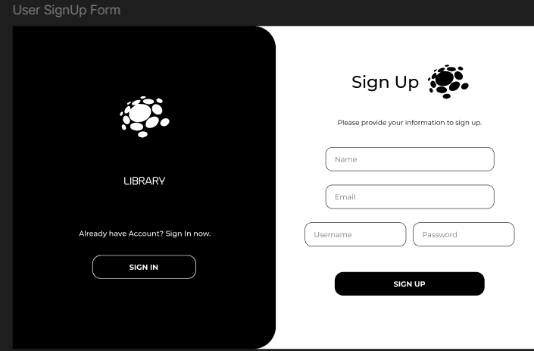User Sign up form:

User sign in form:

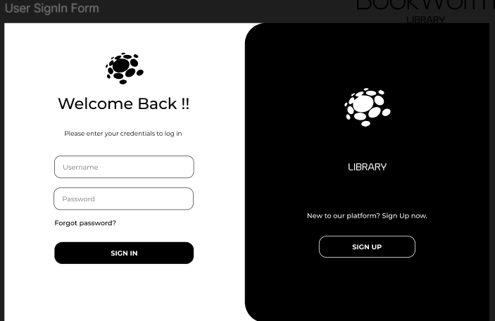

User password Reset:

User Borrowed Book:

User Returned Book:

Returned Book confirmation:

## Hardware Interfaces

The software shall interface with the following hardware components:

Barcode Scanner: To read book ISBNs and member IDs

Receipt Printer: To print receipts

## Software Interfaces

The system will interface with a MySQL relational database to store and retrieve all application data.

## Communications Interfaces

The system will use the standard HTTP/HTTPS protocol for communication between client browsers and the web server.

# System Features

This section details the functional requirements of the system, organized by feature.

## System Feature 1

4.1.1 Description and Priority

Allows librarians to manage the library's book collection.

Priority: High.

4.1.2 Stimulus/Response Sequences

<List the sequences of user actions and system responses that stimulate the behavior defined for this feature. These will correspond to the dialog elements associated with use cases.>

4.1.3 Functional Requirements

REQ-1: The system shall allow authorized users to add new books with details including ISBN, Title, Author, Publisher, and Quantity.

REQ-2: The system shall provide search functionality to find books by Title, Author, or ISBN.

REQ-3: The system shall allow authorized users to edit the details of existing books.

REQ-4: The system shall display an error message if a user tries to save a new book without a title.

## System Feature: Circulation Management

4.2.1 Description and Priority: Manages the lending and returning of books.

Priority: High.

4.2.2 Stimulus/Response Sequences: A librarian scans a member's card and a book's barcode to initiate a check-out transaction.

4.2.3 Functional Requirements:

REQ-5: The system shall allow librarians to check out a book to a member using their member ID and the book's ISBN.

REQ-6: The system shall record the check-out date and automatically calculate the correct due date.

REQ-7: The system shall allow librarians to process the return of a book.

REQ-8: Upon return, the system shall check if the book is overdue and trigger the fine calculation feature if necessary.

# Other Nonfunctional Requirements

## Performance Requirements

Book search results shall be retrieved from the database and displayed to the user within 3 seconds under normal load conditions

## Safety Requirements

<Specify those requirements that are concerned with possible loss, damage, or harm that could result from the use of the product. Define any safeguards or actions that must be taken, as well as actions that must be prevented. Refer to any external policies or regulations that state safety issues that affect the product’s design or use. Define any safety certifications that must be satisfied.>

## Security Requirements

Access to the system shall be restricted to authorized users via a unique username and password.

The system shall support different user roles (Librarian, Administrator) with distinct permissions to access different features

## Software Quality Attributes

Availability: The system shall be available 99% of the time during the library's normal operating hours.

Usability: The user interface should be intuitive and require minimal training, enabling a new user to perform basic circulation functions within one hour.

## Business Rules

These are the operating principles that the system must adhere to:

Membership in the library shall be free for all members of the campus community.

A member cannot borrow more than 5 books at one time.

The standard loan period for a book is 21 days.

Members with outstanding fines exceeding a configurable limit (e.g., $10.00) are not permitted to borrow new books.

# Other Requirements

*This section defines additional requirements not covered elsewhere in the SRS, including database, internationalization, legal, and reuse objectives for the Library Management System (LMS).*

*9.1 Database Requirements*

* *The system shall use a MySQL (or PostgreSQL) relational database to store all persistent data, including books, users, borrowing records, and transaction logs.*
* *The database shall support ACID properties (Atomicity, Consistency, Isolation, Durability) to maintain data integrity.*
* *Passwords shall be stored using SHA-256 encryption with salting.*
* *The system shall perform daily automated backups of the entire database.*
* *All book transactions shall maintain referential integrity between Book, Member, and Borrow_Record tables.*
* *The database shall support stored procedures and triggers to automate fine or overdue calculations.*

*9.2 Internationalization Requirements*

* *The system’s interface language shall be English by default, with future capability to support Bengali and Spanish for diverse users.*
* *Date and time formats shall adapt to the user’s locale (e.g., MM/DD/YYYY for U.S. users, DD/MM/YYYY for international users).*
* *The system shall allow Unicode character input for book titles and author names to support international publications.*

*9.3 Legal and Regulatory Requirements*

* *The LMS shall comply with FERPA (Family Educational Rights and Privacy Act) to protect student borrowing data.*
* *The software shall display a Terms of Use and Privacy Policy agreement during user registration.*
* *The system shall not share or sell user data to third parties.*
* *Any digital resources integrated into the LMS (e.g., e-books or journals) must respect copyright and licensing laws.*

*9.4 Security Requirements*

* *The system shall require authentication via a secure login system.*
* *All communications between client and server shall use HTTPS encryption.*
* *Access shall be role-based (Administrator, Librarian, Member) with clearly defined permissions.*
* *The system shall log all administrative actions and maintain a security audit trail.*
* *Automatic logout shall occur after 10 minutes of inactivity for security purposes.*

*9.5 Reuse Objectives*

* *The user authentication, database connection, and book management modules shall be designed for reuse in future academic systems.*
* *The fine calculation algorithm and report generation component may be reused in other institutional management software.*
* *The modular architecture (MVC pattern) shall enable easy expansion of features like e-book support or RFID integration.*

*9.6 Performance Requirements*

* *The system shall support up to 1,000 concurrent users without performance degradation.*
* *All search operations (e.g., book title, author, ISBN) shall execute within 2 seconds under standard load.*
* *The system shall be optimized for operation on both desktop and mobile browsers.*

*9.7 System Evolution*

* *The system architecture shall allow integration with future mobile apps or cloud services.*
* *Documentation and APIs shall be maintained for future developers to extend system functionalities.*
* *The LMS shall be compatible with futur*e upgrades to the underlying DBMS and web technologies.

Appendix A: Glossary

| Term / Acronym | Definition |
| --- | --- |
| LMS | Library Management System |
| SRS | Software Requirements Specification |
| DBMS | Database Management System |
| CRUD | Create, Read, Update, Delete |
| SQL | Structured Query Language |
| ISBN | International Standard Book Number |
| UI | User Interface |
| MVC | Model-View-Controller Architecture |
| FERPA | Family Educational Rights and Privacy Act |
| HTTPS | Hypertext Transfer Protocol Secure |
| TBD | To Be Determined |
| API | Application Programming Interface |

Appendix B: Analysis Models

The following analysis models represent the logical and structural design of the Library Management System:

1. Context Diagram – Illustrates external entities such as Librarian, Member, and Administrator interacting with the system.
2. Level-0 Data Flow Diagram (DFD) – Displays the main processes: Book Management, Member Management, and Borrow/Return Processing.
3. Entity-Relationship Diagram (ERD) – Shows key entities (Book, Member, Borrow_Record, Fine) and their relationships.
4. Use Case Diagram – Defines how each user role interacts with the system (e.g., Borrow Book, Return Book, Add New Book, Pay Fine).
5. Class Diagram – Defines system classes such as Book, User, Transaction, and Librarian.

Appendix C: To Be Determined List

| TBD # | Description | Resolution Target Date | Assigned To |
| --- | --- | --- | --- |
| TBD-1 | Decision on cloud hosting provider (AWS, Azure, or on-premise server) | Nov 2025 | Project Manager |
| TBD-2 | Final selection of language localization framework | Dec 2025 | Developer Team |
| TBD-3 | Integration of digital library/e-book module | Jan 2026 | Development Team |
| TBD-4 | Backup frequency and retention policy | Nov 2025 | Database Administrator |
| TBD-5 | Implementation of RFID-based book tracking | TBD | Technical Lead |